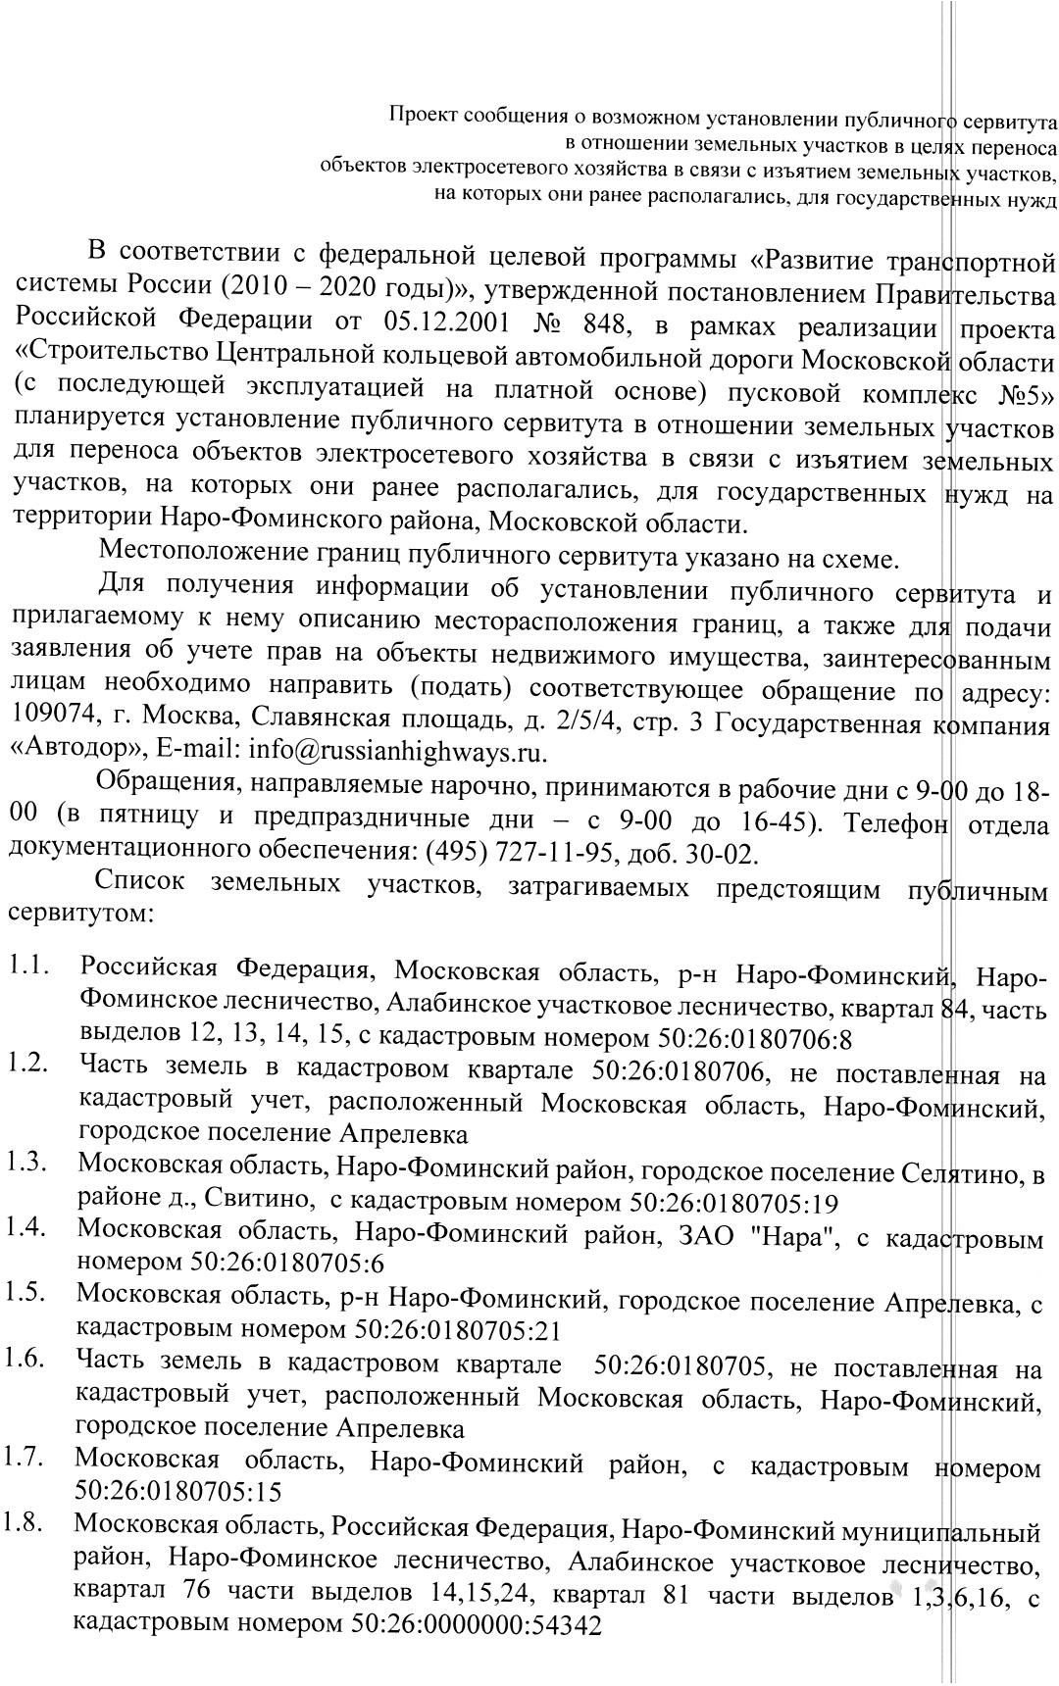
8645-03
28.05.2020

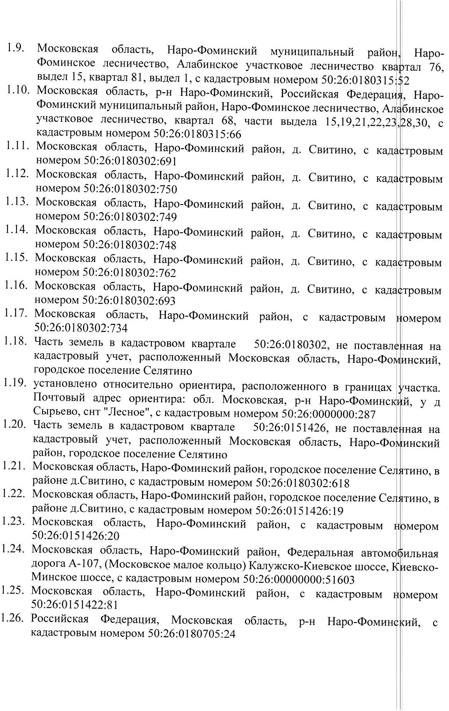

Muah fpahmy semeuahofo yuactka ha kaДactpobom muahe teppmtopmm Дur yctahobuehmr my6umuhofo cepbmtyta c yeuad mepeyctpouctba o6aekta Bu 35 kB "Kuehobo-Emyobo"

деревня Свитино

50:26:0180302:618
50:26:0180302:753

50:26:0151426:19
53
50:26:0151426:20 52
51
54

49 55
50:26:0180302:734
50:26:0180302

50:26:0180302:693

50:26:0000000:287 50
50:26:0151422:81

50:26:0151422

50:26:0180302:762

48 50:26:0180302:762
56
47 50:26:0180302:750

57 50:26:0180302:691
50:26:0180302:748
46 50:26:0180302:749

58

45
59

44
60

43
50:26:0180315:66
61

42
62

41 50.26.2.20
63

50:26:0000000:50439(44)

деревня Тимонино

40
64

39
50:26:0180315:66 65

50.00.2.576

38
66

37
67

36
68

35
69

34

50:26:0151612 70
33
71

32
17365621
50:26:0000000:51603

72

31
73

30
50:26:0180315:52
74

29

75

28
76

27 77

26

25

78
50:26:0000000:54342

79

24 80

23

50:26:0180315

50:26:0000000:50439

81

22
82

50:26:0151610 21

83
20 50:26:0180301
50:26:0151422

84

19

деревня Тимонино

50:26:0151611

18

50:26:0180705:15
50:26:0180705:12
85

50:26:0180705:21
86

17 87

16
88

50:26:0180705

50:26:0180705:24

50:26:0180705:6

50:26:0180705:10

50:26:0180705:17

50:26:0180705:5

15
89

14 90 50.26.2.20

50.00.2.576

50:26:0151606

13
91

12 92
50:26:0000000:51603

Vcuobhɵe o6oshauehmr:
- fpahmya kaДactpobofo kbaptaua
- cyyectbydyar uacta fpahmyɵ, mmedymecr b EFPH cbeДehmr o kotopou Дoctatouhɵ Дur

деревняЖёдочи

50:26:0151608

11

93

10 94
9

8

50:26:0180705:19

95

96

50:26:0180706

ompeДeuehmr ee mectomouowehmr
- bhoba o6pasobahhar uacta fpahmyɵ, cbeДehmr o kotopou Дoctatouhɵ Дur ompeДeuehmr ee mectomouowehmr (cepbmtyt)
50:26:0000000:51603 - kaДactpobɵu homep semeuahofo yuactka, mo cbeДehmrm EFPH
50:26:0151608 - o6oshauehme kaДactpobofo kbaptaua
50.26.2.20
- homep m o6oshauehme fpahmyɵ 3OYHT

50.26.2.20

50:26:0151601
7 97

6 98

5 99

50:26:0180706:8

1 - o6oshauehme m homep xapaktephou toukm semeuahofo yuactka (cepbmtyt)

- cxematmueckoe o6oshauehme omopɵ Bu 35 kB
- oca Bu 35 kB "Kuehobo-Emyobo"

- mouoca otboДa abtoДopofm ØeДepauahofo shauehmr A-113

- fpahmyɵ haceuehhɵx myhktob
4

50.00.2.576

100

3

2

101

102

50:26:0151610
50:26:0180706:8

50:26:0180706:1

1
50:26:0151422:98

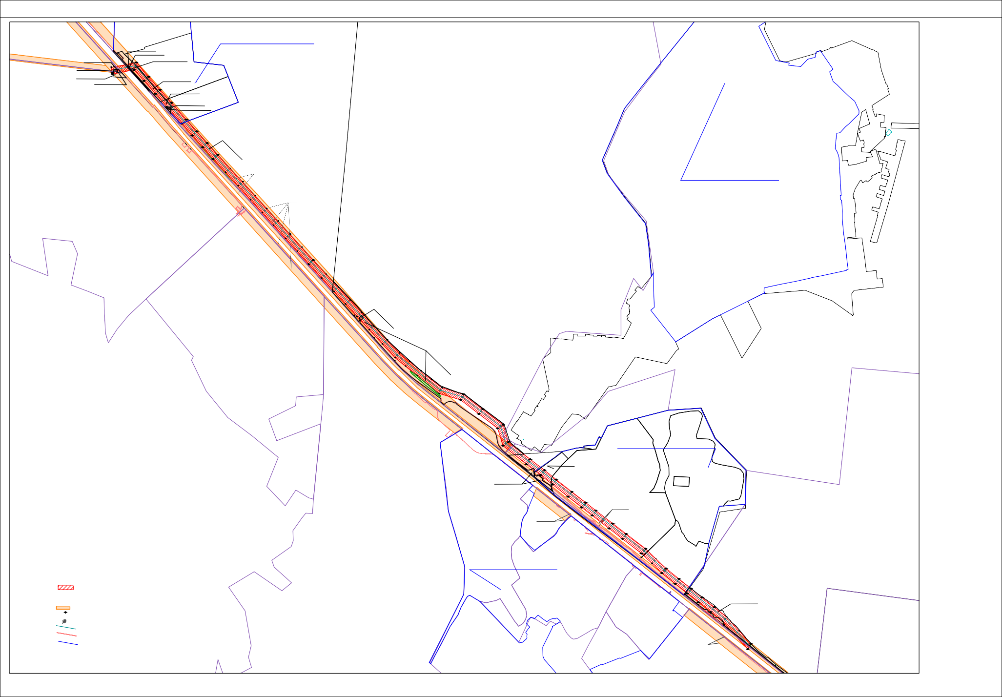

50:26:0180706:5
50:26:0180

Machta6 1:5000 8opmat umcta A0

